Assignment Cover Sheet:

Student’s name | (First name) | (Last name)
Module name | Samuel | Durrant
Title of assignment | A software engineering approach to the desk management problem at Leonardo
Complete Word Count in my assignment | 3166
Date submitted | 20/03/2026

All work must be submitted by the due date. If an extension of time to submit work is required, a Mitigating Circumstances Extension Form must be submitted.
Has an extension been approved?  Yes  No

If yes, please give the new submission date ….…/..…./…….

IMPORTANT: THIS STATEMENT MUST BE READ & SIGNED
Academic Integrity Statement
Academic integrity and honesty are fundamental to the academic work you produce at the University of Roehampton. You are expected to complete coursework which is your own and which is referenced appropriately. The university has in place measures to detect academic dishonesty in all its forms. If you are found to be cheating or attempting to gain an unfair advantage over other students in any way, this is considered academic misconduct and you will be penalised accordingly.

I declare that the work I am submitting is my own work, is properly referenced and has not been submitted elsewhere
Student Signature (Full Name): Samuel Durrant

Date: 20/03/26

Table of Contents

Table of Figures

Task One: Web Development Project

Problem Statement
Modern hybrid working environments require suitable and flexible desk management systems to efficiently allocate desk space, especially in the case of Leonardo where hot-desking is prominent in the offices. Many organisations face challenges such as desk conflicts and lack of visibility over bookings and existing desk management software is often problematic, causing Leonardo to have had to migrate systems to a newer system, which is still failing to meet their full requirements. For example, the current system is difficult to use and results in a lack of adoption.
The Desk Booking application was developed in order to solve these issues by providing an easy to access web platform where users can book desks without conflict, manage their desk bookings and also have them managed by their managers (which is important to Leonardo, as often projects will reserve their own desk spaces).

Application Scope:
The system is designed for internal use at Leonardo and includes:
- User authentication (login/logout)
- Desk booking functionality
- Booking management (edit/delete)
- Administrative features (manage desks for all users and sites)
- Database persistence
The application supports two roles:
- Administrator: Full control over desks, sites, and all bookings
- User: Can create, edit, and delete their own bookings

System Design and Architecture:
The Desk Booking system utilises a Model, View, Controller architecture in Flask. The Model, View, Architecture is the standard when it comes to creating full stack applications with an SQL database, such as sqlite in this instance. This architecture “emphasizes a separation between the software's business logic and display” which provides for “a better division of labor and improved maintenance.” (Mozilla, 2023)
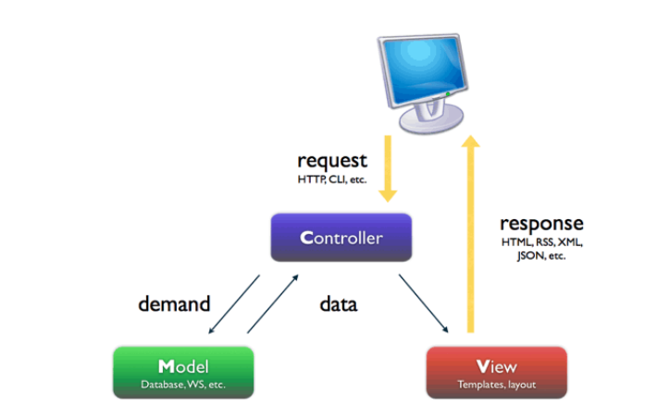
Figure 1 - The Model, View, Controller Architecture (Pop & Altar, 2014)
The application was developed using the following technologies:
- Models: Database structure using Flask-SQLAlchemy
- Views (Templates): HTML with Jinja2 templating
- Controllers (Routes): Flask route handlers managing logic
- Python (Flask framework)
- Flask-SQLAlchemy (ORM)
- SQLite (database)
- HTML, CSS, JavaScript (frontend)
The application utilises a relational database that is normalised to the 3rd Normal Form. This means that the 2nd and 3rd normal forms are met, but also that “fields that don't depend on the key” are eliminated (Microsoft, 2025). The Entity Relationship Diagram can be seen in Figure 2.
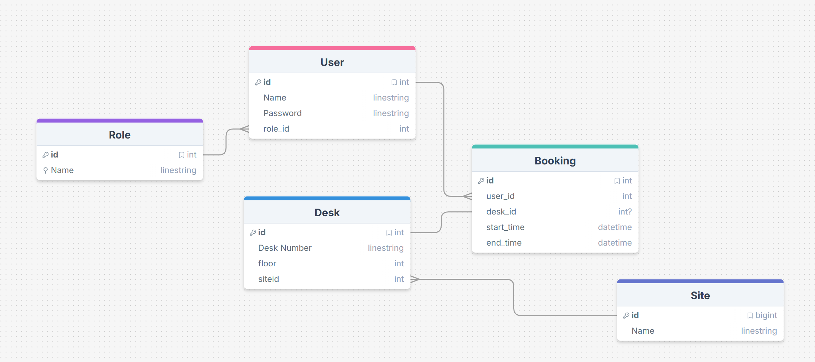
Figure 2 - Desk Booking Software Entity Relationship Diagram
As demonstrated, the database consists of one-to-one and many-to-one relationships, but never a many-to-many (as this would violate the normal forms and constitutes poor database design) and has 5 tables in total. This design also allows for and enforces referential integrity, which is key in well-designed of databases.
The desk number was not selected as the primary key for the Desk table due to the fact that it is common at Leonardo for desk numbers to change as new desks are added and others are removed.

Application Structure:
The application is designed to be modular and consists of several key components on both the frontend and backend.

Backend Structure:
- Models.py - Defines the database schema and relationships and is used in the MVC architecture
- Db.py - Handles database initialisation and CRUD functions.
- Main.py – Flask app creation (factory) and route definitions
- Run.py – the main entry point for running the web server.

Frontend Structure
- Templates (Jinja2)
  - Base.html – forms the layout and sidebar navigation
  - Dashboard.html – User landing page
  - Book_desk.html – Desk booking interface
  - Edit_bookings.html – Enables the edits of existing bookings
  - Delete_bookings.html – Enables the deletion of existing bookings
  - Manage_desks.html – Enables the creation, editing and deletion of desks (administrator access required)
  - Manage_sites.html – Enables the creation, editing and deletion of sites (administrator access required)
- JavaScript
  - Handles dynamic table rendering for relevant pages
  - Handles pagination for relevant pages
  - Handles search algorithms for relevant pages
  - Handles form submission for relevant pages
  - Uses Fetch to communicate with API
- CSS
  - Provides a base styling for all of the pages and the sidebar.

Programming Techniques and Concepts:
Throughout the creation of the Desk Booking Software, various programming techniques and concepts were used:
- Object-Oriented Programing (OOP)
  - Models such as the User, Desk and Site are implemented in the form of a class through SQLAlchemy to support the MVC architecture
- Database Abstraction (ORM)
  - SQLAlchemy allows for interaction with the database without the need to write raw Structured Query Language (SQL) queries, improving code readability and maintainability
- Authentication and Security
  - Passwords are hashed using Werkzeug hashing algorithms
  - Session management is in place for session persistence and to block access to routes without an active session.
  - Role-based access control restricts access to administrative features
- Form Handling and Validation
  - HTML forms are sent with POST requests
  - Server-sided validation ensures correct datetime formats and prevents against malformed requests
  - Client-side validation reduces the need for server-sided validation as requests are blocked by the client first if they are unsuitable. This also enhances user experience.
- Pagination and Searching
  - Server-sided pagination guarantees performance for the user
  - Fuzzy searching implementation allows for easy searching for desks and staff members
- Error Handling
  - Due to the high amount of front-end error checking, the vast majority of errors can be handled gracefully without causing backend crashes

Application Screens Overview

Login Screen
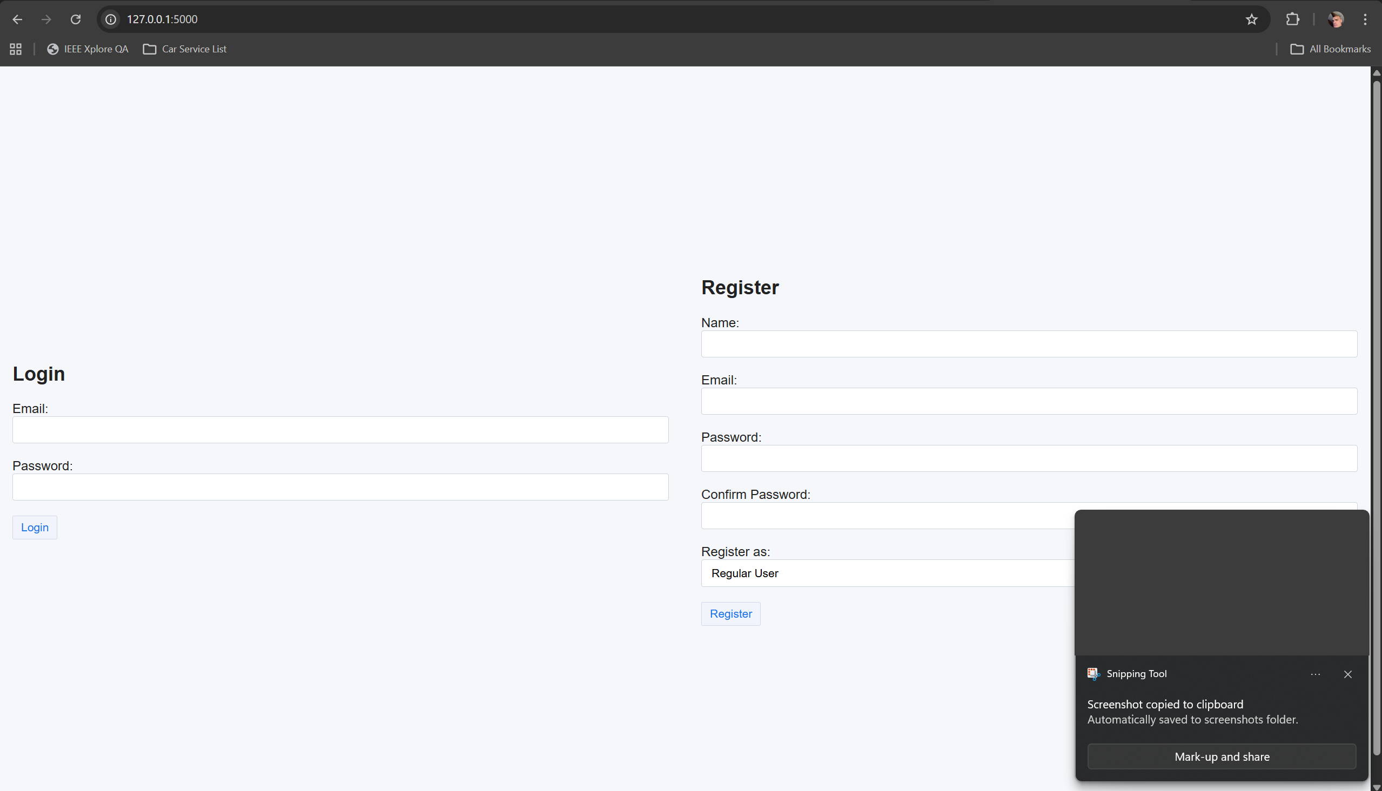
Figure 3 - Login and Registration Screen

Dashboard
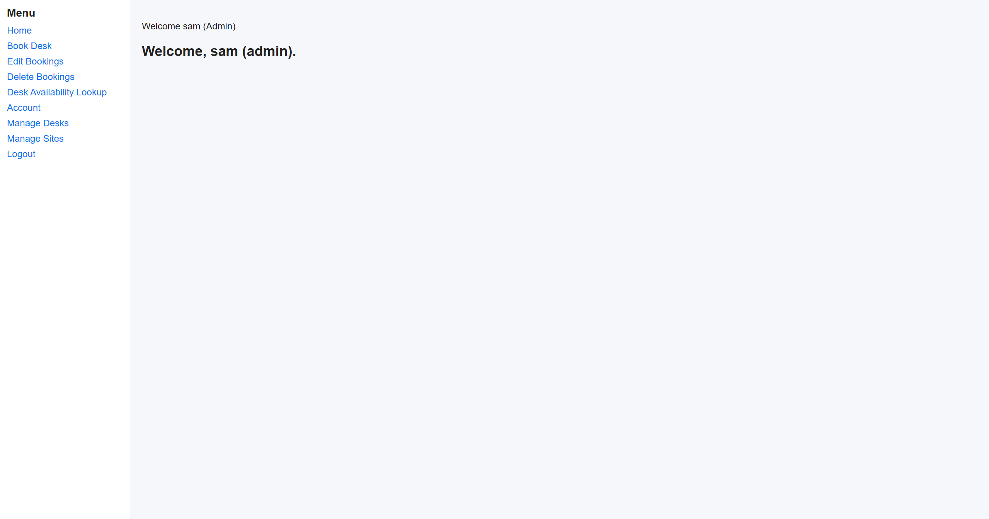
Figure 4 - Main dashboard screen

Book Desk Page
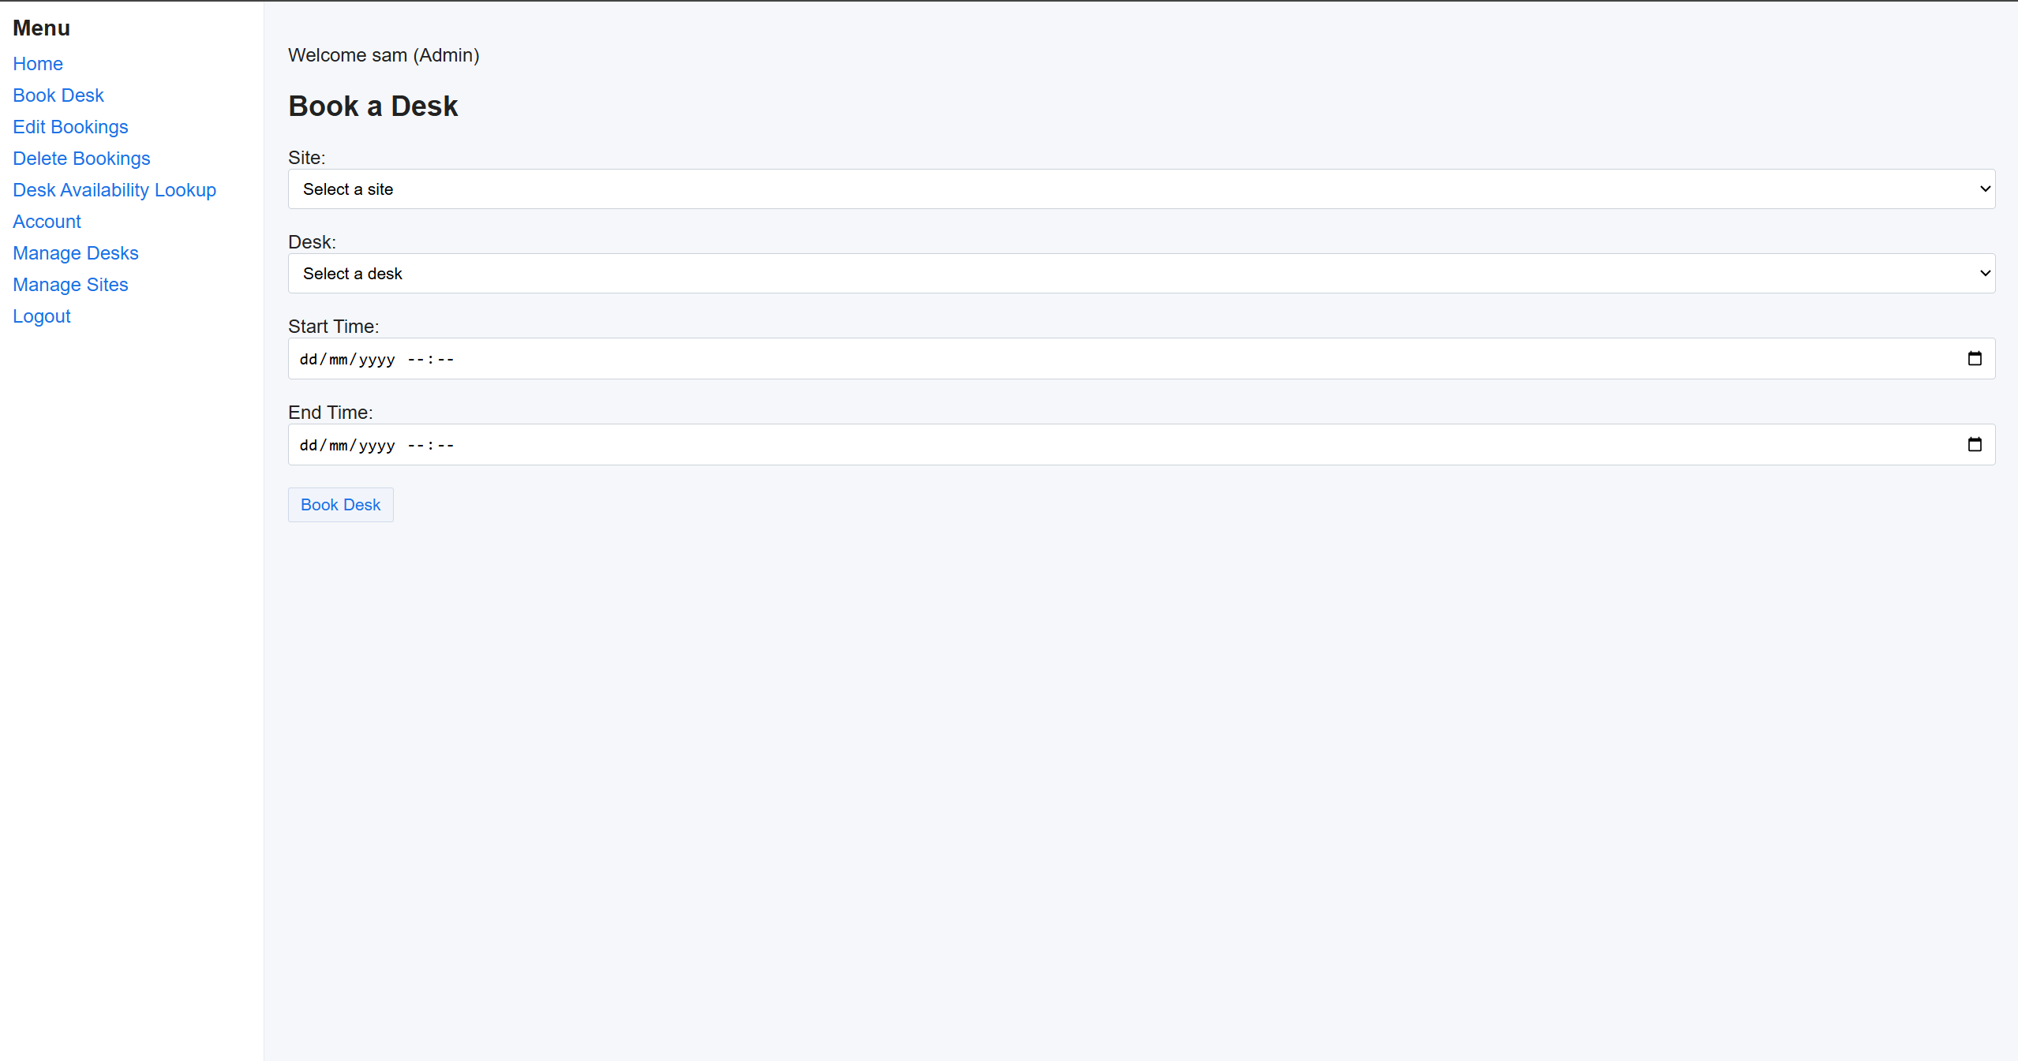
Figure 5 - Desk booking page

Delete Booking Page
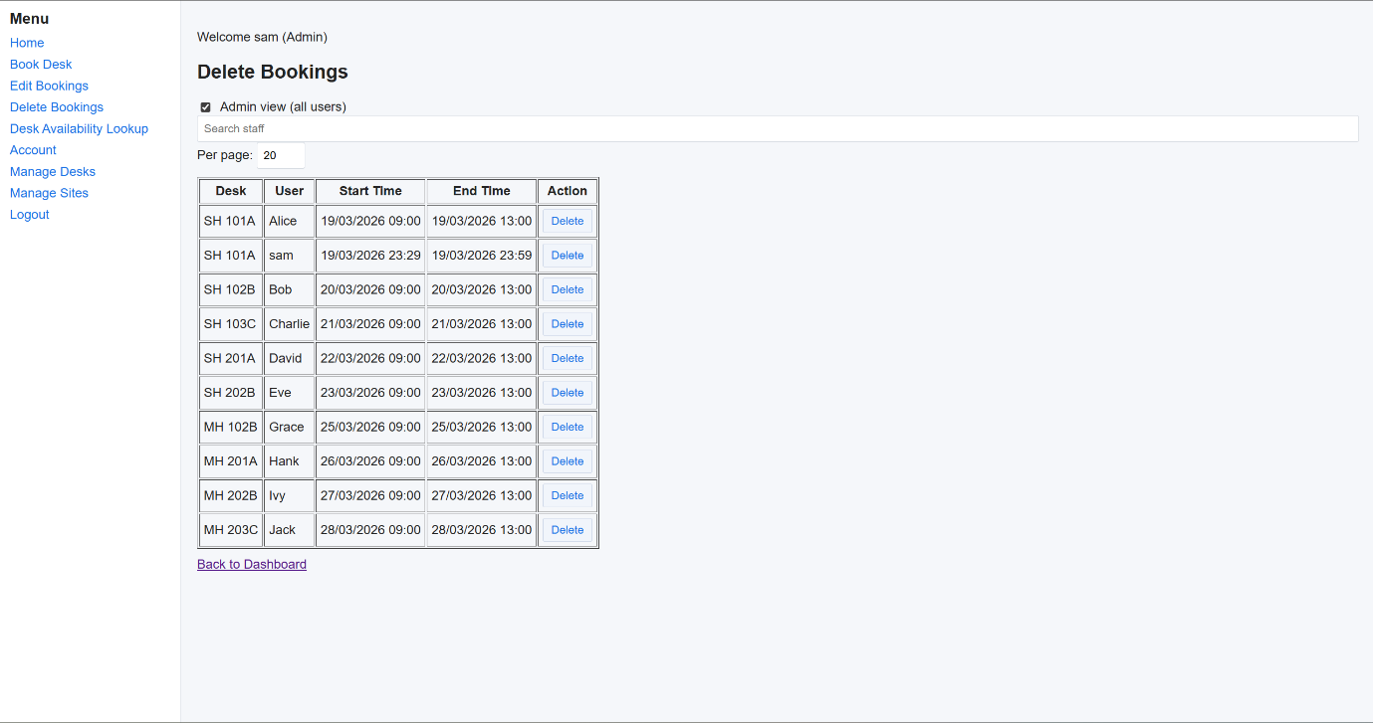
Figure 6 - Delete Booking Page - Admin View
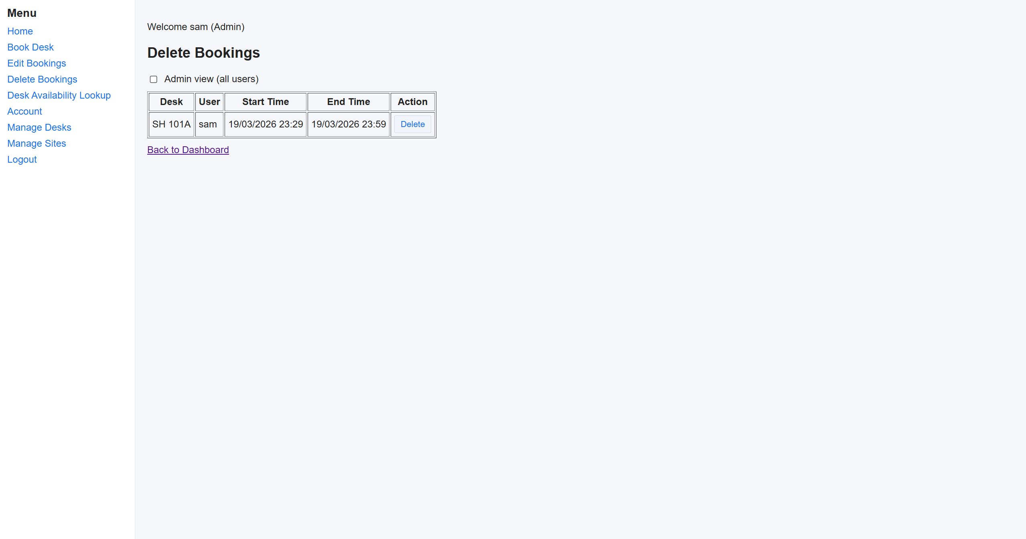
Figure 7 - Delete Booking Page - Normal View

Edit Booking Page
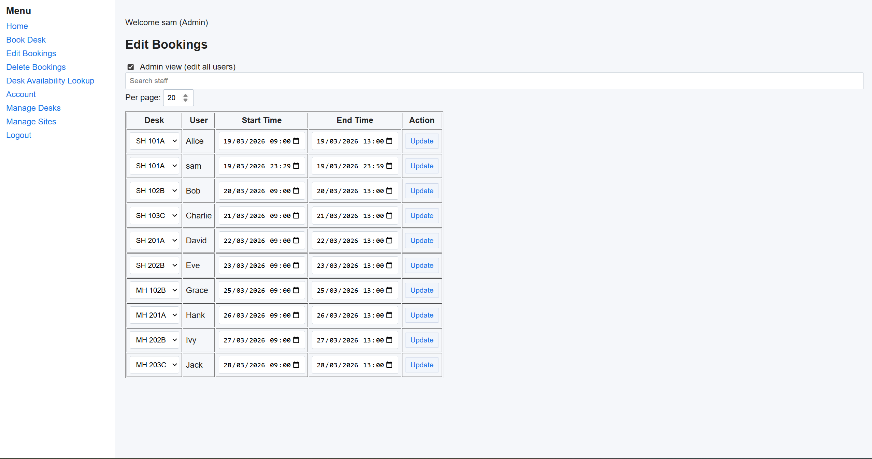
Figure 8 - Desk Booking Edit Page - Admin View
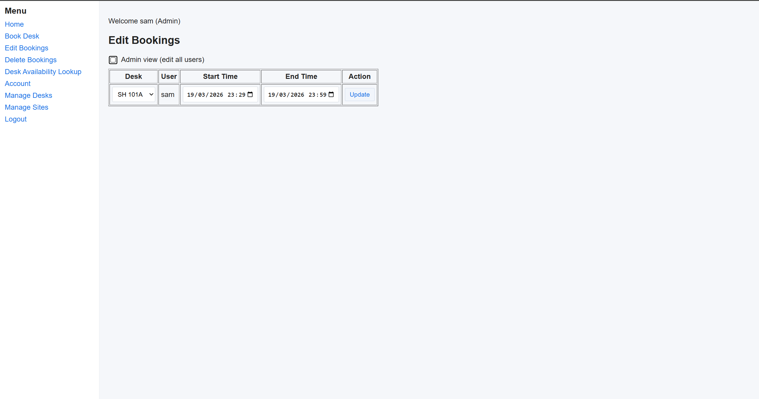
Figure 9 - Desk Booking Edit Page - Normal View

Account Management
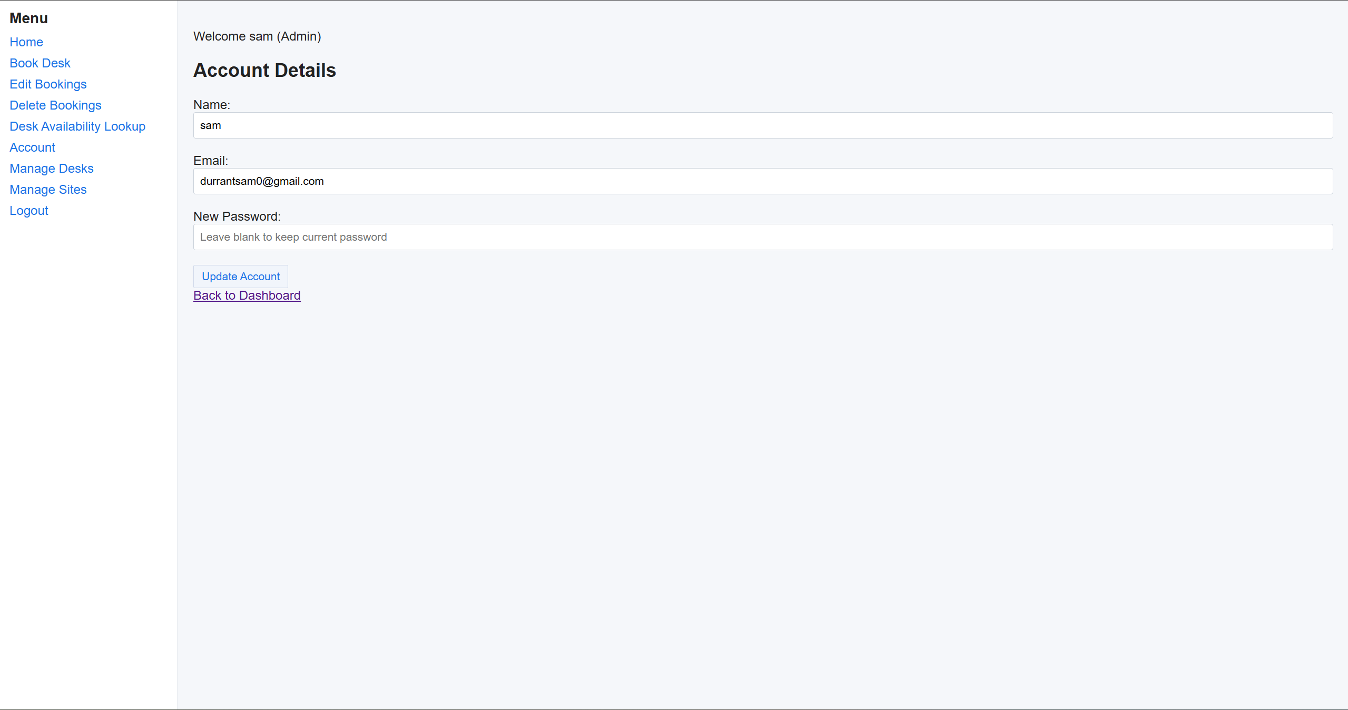
Figure 10 - Account Details Editor

Desk Lookup
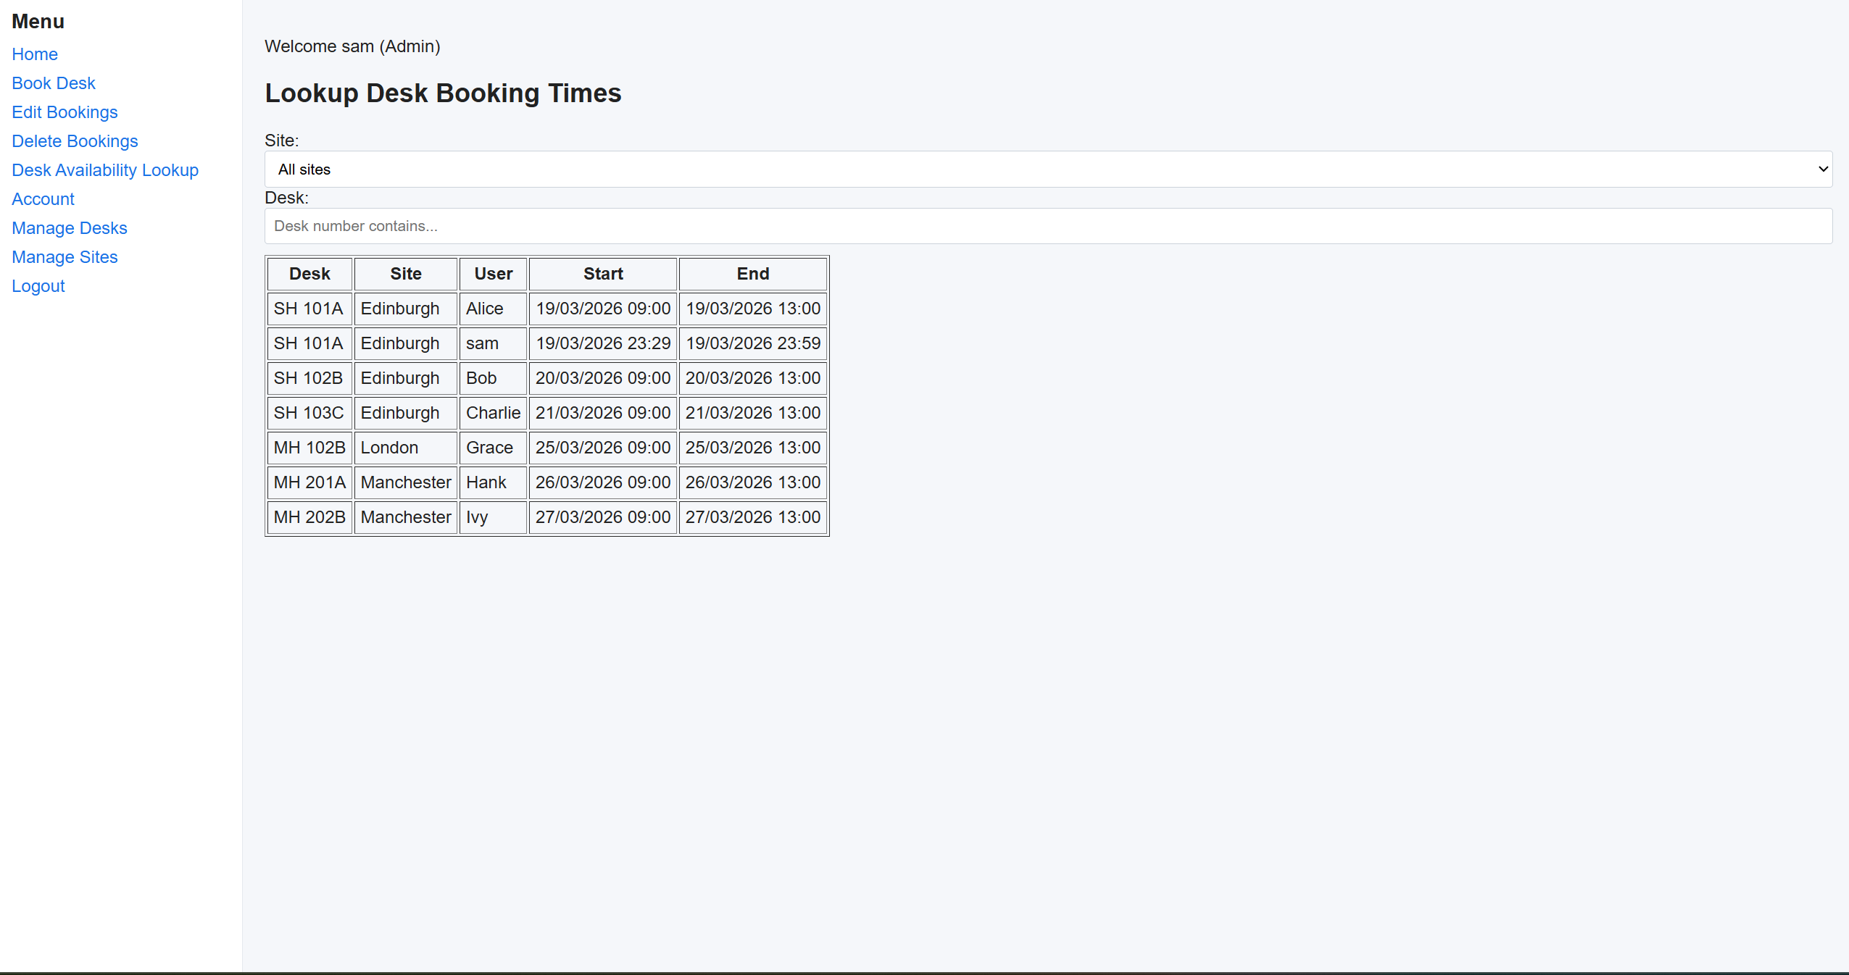Figure 11 - Desk Availability Lookup

Admin Panels
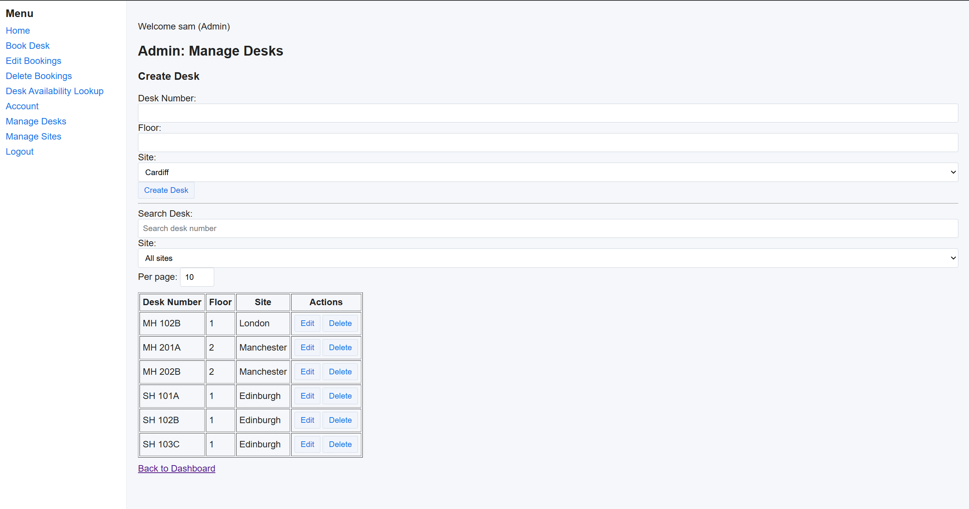
Figure 12 - Desk Management (Admin)
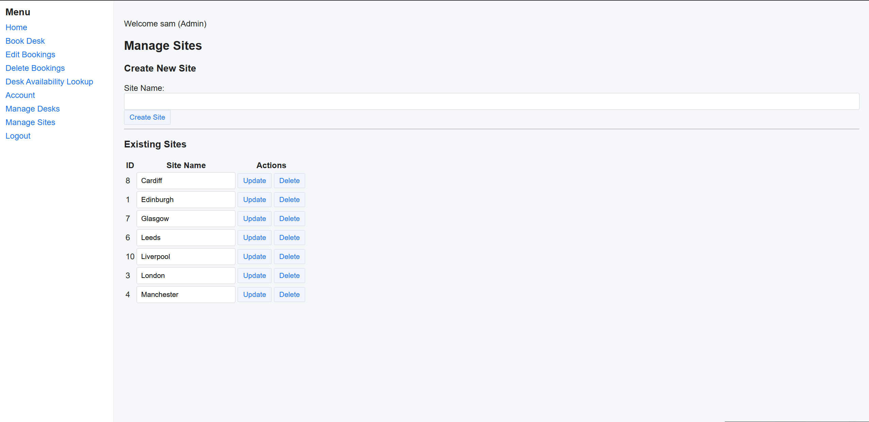
Figure 13 - Site Management (Admin)

User Manual

Login
- Enter email and password
- Click “Login”

Booking a Desk
- Navigate to “Book Desk”
- Select a site
- Choose a desk
- Enter start and end times
- Submit form

Editing a Booking
- Go to “Edit Bookings”
- Modify desk or time
- Click “Update”

Deleting a Booking
- Go to “Delete Bookings”
- Click “Delete” next to the booking

Check Desk Availability
- Go to the page to check desk availability
- Enter any relevant search parameters
- Look at the timings to see if the desk you want to book will be booked at the time you need it

Admin Features
- Access “Manage Desks” or “Manage Sites”
- Create, update, or delete entries

How To Run The Application

Local Setup
- Install dependencies:
pip install -r requirements.txt
- Run database setup:
python reset_db.py
- Start the application:
python run.py
- Access via browser:
http://127.0.0.1:5000

Production Deployment (Render)
- Add gunicorn to requirements.txt
- Set start command:
gunicorn run:app
- Deploy via GitHub repository

Use the pre-existing hosted version
- Navigate to https://sw-proj-code.onrender.com/ in the web browser.

Testing:
Throughout the development of the Desk Booker application, as part of the Agile Practices that were followed throughout development, an iterative testing approach was followed. Rather than leaving testing until the end, each feature was tested immediately after implementation and then re-tested as functionality that may affect different features was added. For example, after implementing the booking system, tests were carried out in order to ensure that desks could be successfully booked and that the inputted data was stored correctly in the database. When validation logic was introduced nearer the end of the project, additional tests were performed in order to ensure that functionality had not been lost, alongside ensuring that the validation logic was working successfully. The ensuring that existing functionality had not been lost is known as regression testing, which is a technique that was applied throughout the entire lifecycle of the Desk Booker application’s development. Further features followed this principle, including but not limited to: live search, pagination and filtering.

Task Two: Agile Practices
The Desk Booker application was developed using agile principles. “Agile is a flexible, iterative approach to project management that emphasizes collaboration, continuous delivery, and adaptability.” (Atlassian, 2025). Although this project was developed individually, several agile principles were applied during development.

Stories:
User stories are a short description of functionality from the perspectives of different types of end user. They help to define requirements in a clear manner and ensure that the system meets the needs of the user.
For this project, these stories were utilised to give a clear definition of work that had to be performed in order to fully meet the scope of the project. Example stories can be seen in Figure 14
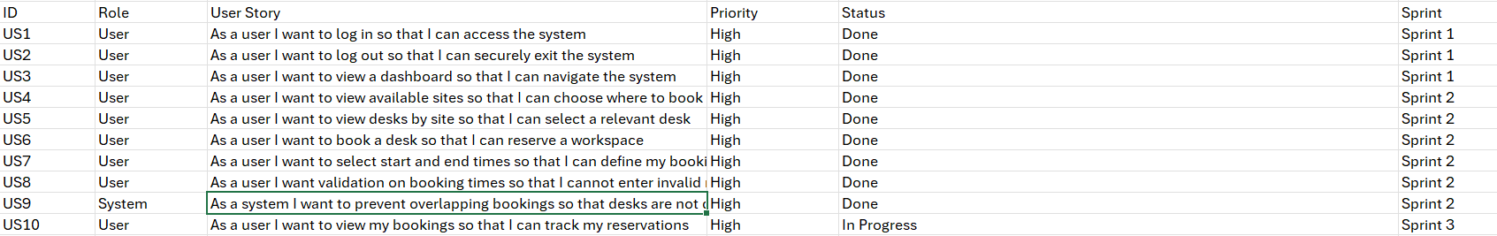
Figure 14 - Example User Stories for Desk Booking System
These stories guided the implementation of features such as the creation of the log in page, the registration and the various pages to perform CRUD operations.

Sprints:
Also demonstrated in Figure 14, a weekly sprint system was utilised in order to manage the amount of work that would be done each week and also provided a timeframe for development. A sprint is defined as being “a time-boxed development interval (typically one month or less) (Kim, 2016) and allows for adaptation for how much work is being done and tracking of what is being worked on.
In this project, development was carried out in stages, similar to sprints:
- Sprint 1: Core database models and user authentication
- Sprint 2: Desk booking functionality
- Sprint 3: Editing and deleting bookings
- Sprint 4: Admin features (manage desks and sites)
- Sprint 5: UI improvements and validation
Each sprint builds on the previous sprint, allowing for testing and refinement during development before moving forward which reduces the complexity of debugging issues in the code.

Kanban-Style task management
Throughout the sprints, each task was marked as “To Do”, “In Progress”, or “Done”. Usually a kanban board tracks this and although a formal tool was not used, a similar approach was followed by maintaining a list of tasks (namely, the stories). Features were implemented one at a time, moving from planning, to development, to testing. Examples of this Kanban-Style task management can be seen again in Figure 14.

Project Artefacts and Evidence
The main artefact for this project is the full source code, which includes:
- Backend logic (Flask application, database models, routes)
- Frontend templates (HTML with Jinja2)
- JavaScript for dynamic interaction
- CSS for styling
The source code is stored in a GitHub repository and deployed using Render, demonstrating version control and continuous deployment. These artefacts provide clear evidence of the development process and implementation of Agile-inspired practices.

Task Three: Agile Overview:

Introduction
Agile software development, as outlined in the other tasks, is a methodology that emphasises flexibility, an iterative process and continuous improvement. Rather than following a rigid approach like some other methodologies, Agile allows for development teams to adapt to changing requirements and to deliver software incrementally. Leonardo demonstrates this through their design stages of software, such as DD0, DD1, DD2, and so on.
In the development of the Desk Booker application, agile principles have been applied loosely through various stages of implementation, testing and refinement of features. In this case, the selected Agile framework of interest is Scrum. Scrum is structured yet adaptable and can be applied to smaller scale projects such as the Desk Booker application, but it also can be utilised in much larger scale projects, as demonstrated by Leonardo.

An Overview of Scrum
“Scrum is one of the most popular agile frameworks, helping teams tackle complex projects by breaking work into smaller, iterative cycles called sprints.” (Atlassian, 2025). It divides development into fixed time blocks, often lasting between 1-4 weeks, known as sprints. These sprints focus on delivering a functional increment of the system. Figure x provides a clear diagram of how Scrum works and how it should be implemented.
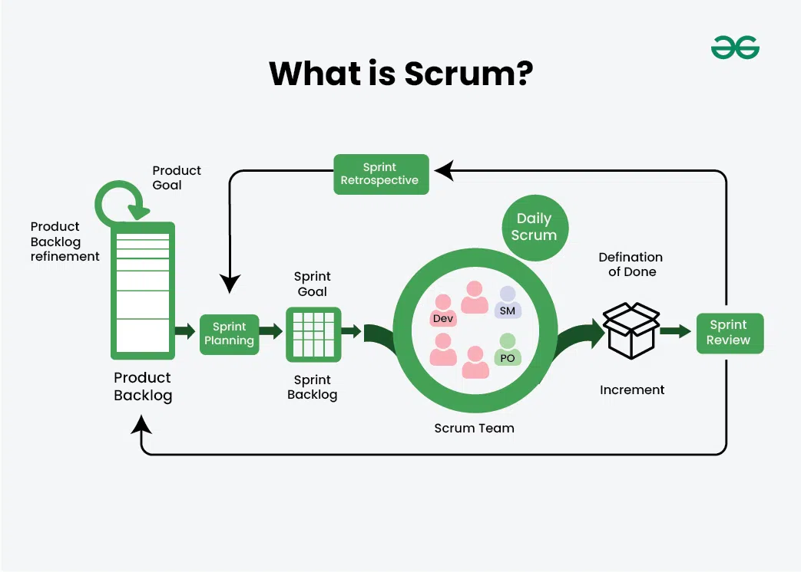
Figure 15 - What Is Scrum? (geeksforgeeks, 2025)

The Key Components of Scrum

Scrum Roles
In Scrum, there are a range of roles that the members of the team assume. These roles are key for ensuring that Agile Scrum is followed in the correct manner, but also for the team members to fully understand their own importance and role within the software lifecycle. These scrum roles “make sure that everyone is able to work together seamlessly” (Cole & Scotcher, 2015)

Project Owner
The project owner is responsible for the definition of requirements and prioritising tasks in the product backlog and assigning tasks to team members.

Scrum Master
The Scrum Master is responsible for ensuring that the team follows Scrum Practices and attempts to remove obstacles for the development team, with an emphasis on facilitating communication

Development Team
The development team implement the features and perform the tasks assigned to them from the backlog by the project owner. They often make decisions on back-end logic and have a large influence over design.
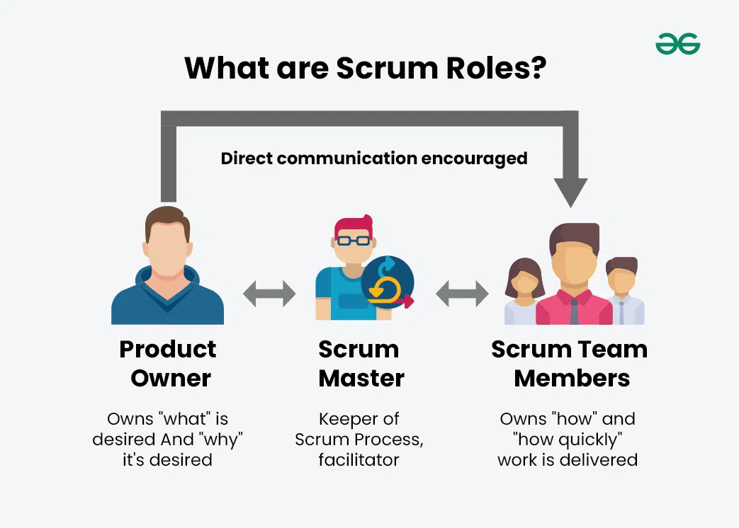
Figure 16 - What are Scrum Roles? (geeksforgeeks, 2025)

Events
As part of Agile Scrum, there are certain events that have to take place to ensure a smooth and correct implementation of Scrum. These events include Sprint Planning. This is where user stories are selected to be implemented within a sprint. There is also a Daily Standup, in which the entire team get together in order to discuss their progress during sprints. During these sprints, team members often discuss what they worked on yesterday, the progress they made and what they are going to work on that day. They also discuss any blocking factors that they may have in order to receive support from other members of the team or to receive guidance to work on another issue until those blocking factors can be lifted.
At the end of each sprint, a Sprint Review is held. These reviews are held in order to demonstrate the completed features and this provides the team a greater visibility about the progress of the project and also provides a time for questions to be asked about the direction of the project given the progress made so far. Shortly after a Sprint Review is held, Agile Scrum teams will hold a Sprint Retrospective. This “retrospective” behaves as a lessons learnt for the sprint that has just been completed. Often, during a retrospective, discussions take place about what went well and what could have gone better. This provides lessons for the team to learn from so that they can perform better in the next sprint.

Artefacts:
As part of Agile Scrum, artefacts are created that enable the team to trace the amount of work that has to be completed in order to complete the project, and the progress being made towards these issues. One example of this is a product backlog, which is “is a list of the new features, changes to existing features, bug fixes, infrastructure changes, or other activities that a team may deliver in order to achieve a specific outcome.” (Agile Alliance, 2015). The product backlog helps teams to work towards their next increment, which is defined as a working version of the application. Increments typically are formed when a new feature has been added to the system and is confirmed to work, which again helps the team to track their progress not only towards the increment, but towards the completion of the system as a whole, as each increment is a step closer to the final product. Increments are also formed typically at the end of each sprint, where all tasks from the sprint backlog, ideally, are completed.

Application of Scrum to the Desk Booker Project
Although Scrum was not formally implemented using tools like Jira, its principles were clearly followed throughout development.
As mentioned previously, the project was developed in iterative stages resembling sprints:

Sprint 1: Core Setup
- Database models (User, Desk, Booking, Site)
- Authentication system (login/logout)
- Basic application structure

Sprint 2: Booking Functionality
- Desk booking form
- Date/time selection
- Validation to prevent invalid inputs
- Backend logic to store bookings

Sprint 3: Booking Management
- Editing bookings (inline updates)
- Deleting bookings
- API endpoints for data loading

Sprint 4: Administrative Features
- Manage desks and sites
- Search and filtering
- Pagination for large datasets

Sprint 5: UI and Enhancements
- Improved user interface
- Error handling and validation
- Responsive design
Each stage resulted in a working increment of the application, which in turn demonstrates Scrum’s principle to deliver usable software, even though not all features are present in the system, frequently. This approach made it easier to identify issues in the Desk Management system more quickly and also made them easier to debug as there was less code to check than there would have been at the end of development.

Comparison with Other Agile Frameworks
While Scrum was good for ensuring that the development of the Desk Booker application was structured, it is important that it is compared with other Agile frameworks such as Kanban and Lean development. Kanban is different from Scrum in that it “supports continuous flow of work, without defined start and finish” (KanbanTool, n.d.), whereas Scrum outlines the flow of work at the start of each sprint, prioritising fast feedback. This approach could have benefited the project by allowing more flexibility when implementing smaller features such as UI improvements or bug fixes, rather than waiting for a sprint cycle to complete.
Lean Development, on the other hand, focuses on eliminating waste and maximising value. In the context of this project, Lean principles could have massively reduced development time, especially in areas where features went out of scope. However lean lacks structured roles and ceremonies that Scrum provides which, in team environments can make coordination more difficult.
This means that Lean development, or a mixture of Scrum and Kanban principles, could have provided a better balance for this project, with attempts to maximise value whilst planning the work that would be undertaken.

Proposed Improvement:
As a result of the lessons learnt from the Desk Booker project, an effective improvement of the Scrum approach would be the intermingling of certain principles from various agile frameworks. An example of this could be the visual aspect of Kanban tracking alongside sprint planning. This is a methodology that Leonardo’s Precision Guidance team utilise, often referred to as “Scrumban”. It allows for greater visibility of task progress whilst maintaining a structured framework, with daily standups, frequent reviews and clearly defined team roles.
In organisations such as Leonardo, where projects are often large, complex and require great traceability in order to ensure that targets are being met in order to be able to continue with work on contracts that the company has won. Implementing a digital Kanban board through Atlassian Jira has allowed team members to track their progress in real time. However, sprints are neglected by some teams at Leonardo, such as the Precision Guidance team. It would potentially be more helpful to utilise sprints with some flexibility, such as adding or removing tasks if the workload is evidently too much, as currently some team members at the company are overburdened with work and the existing framework is likely the cause of this. This is also not aided by the daily standups, which often over-run leaving the team less time to work. Leonardo could cease using daily standups in order to track progress, especially since a Kanban board is already in place.

References
Atlassian, 2025. Agile Best Practices and Tutorials. [Online]
Available at: https://www.atlassian.com/agile
[Accessed 19 March 2026].
Kim, G., 2016. The DevOps handbook: how to create world-class agility, reliability, & security in technology organizations. 1st ed. s.l.:IT Revolution Press, LLC.
Microsoft, 2025. Database normalization description - Microsoft 365 Apps.. [Online]
Available at: https://learn.microsoft.com/en-us/troubleshoot/microsoft-365-apps/access/database-normalization-description.
[Accessed 19 March 2026].
Mozilla, 2023. MVC. [Online]
Available at: https://developer.mozilla.org/en-US/docs/Glossary/MVC
[Accessed 19 March 2026].
Pop, D.-P. & Altar, A., 2014. Designing an MVC Model for Rapid Web Application Development☆, s.l.: ScienceDirect.

